Fiscal Year 2015
U.S.C. Section 5310
Enhanced Mobility of Seniors and Individuals with Disabilities
Grant Application Manual
5310


Central Florida Regional Transportation Authority
Table of Contents
Introduction 4
Application Process and Timeline 4
Background 5
Urbanized Orlando and Kissimmee 5310 Priorities 5
Obligation of Grant Funds and Reimbursement of Project Costs 6
Eligibility 6
Threshold Criteria 6
Locally Developed and Coordinated Human Services Transportation Plan 6
Eligible Projects 7
Urbanized Orlando Map 9
Urbanized Kissimmee Map 10
Legal Authority and Fiscal & Managerial Capability 11
Service Across Urbanized/Non-Urbanized Area Boundaries 11
Americans with Disabilities Act (ADA) 11
Administrative Requirements 11
Matching Funds for Section 5310 12
Operating Assistance Matching Funds 12
Grant Award Process 12
Project Evaluation and Selection Process 12
Project Evaluation Criteria and Scoring 13
Program Performance Measures 13
Application Instructions 15
Checklist 15
Standard Form 424 16
5310 Budget Calculations 20
Vanpool Budget 20
20
Project-Related Operating Expenses 21
Project-Related Revenue 21
Local Match 23
Current Vehicle Inventory 24
Anticipated / Requested Vehicles 24
Exhibit “A” – Current System Description 25
Exhibit “B” – Fact Sheet (Quick Reference) 26
Exhibit “C” – Annual Operating Report (AOR) 27
Exhibit “D” – Proposed Project Description 35
Exhibit “E” – CTC Coordination Contract 37
Exhibit “F” – Single Audit, or Certification of Exemption 38
Exhibit “G” – Coordinated Public Transit-Human Services Transportation Plan 39
Appendix 40
Glossary 40
Sample Resolution Form 42
Required Cover Letter 43
List of Clearinghouses / Regional Planning Councils 44
LYNX Contacts 44

Introduction
This application manual pertains to applications for Federal assistance under U.S.C. Section 5310, Formula Grants for the Enhanced Mobility of Seniors and Individuals with Disabilities Program, as administered by the Central Florida Regional Transportation Authority (dba LYNX). It contains program information, application forms, exhibits, and instructions.
This announcement is available on the LYNX website at: www.golynx.com (search keyword: 5310), also at http://www.golynx.com/news-events/event_detail.stml?portalProcess_dd_0_1_1=showPublicEvent&calendar_entry_id=2678. LYNX will respond to any questions by posting to their website the questions and responses so that all applicants can benefit from any additional information.
Comments or questions related to the 5310 program or the application process may be sent to: mokeefe@golynx.com; with the message heading “LYNX 5310 Comments/Questions”. The deadline for submittal of questions related to the solicitation must be received by 2:00 p.m. on Friday, September 11, 2015.
Applicants should submit one (1) original proposal. Proposals are to be addressed as follows for either mail or hand delivery (hand delivery is recommended to ensure on-time receipt):
LYNX
Attn: GRANTS
5310 Grant Application
455 N. Garland Ave.
Orlando, FL 32801

Application Process and Timeline
Event | Date
Release of Solicitation for Projects | July 31, 2015
LYNX 5310 Application Workshop  Release of Application Instructions | August 14, 2015
CTC Meetings | August 24 – September 11, 2015
Questions & Clarifications Due | September 11, 2015 @ 2:00 PM EST
Project Proposals Due | September 18, 2015 @ 5:00 PM EST
Notice of Intent to Award 5310 Funding  (subject to LYNX Board Approval) | September 29, 2015
LYNX Board of Directors Meeting | November 12, 2015
Targeted Notice to Proceed Start  Execute Sub-Recipient Agreements | Fiscal Year 2016

Background
In 2012, Congress passed a new two-year transportation bill. The Moving Ahead for Progress in the 21st Century Act (MAP-21) became effective October 1, 2012 and replaces the Safe, Accountable, Flexible, Efficient Transportation Act, a Legacy for Users (SAFETEA-LU) which expired on September 30, 2012.
With the advent of MAP-21, urban areas over 200,000 in population are now direct recipients of FTA Section 5310 funds. As a result, LYNX has been selected to serve as the designated recipient of the Section 5310 funds for the Orlando and Kissimmee urbanized area.
In addition, MAP-21 has made a number of changes including repealing the Section 5317 New Freedom Program. The Section 5310 grant program now incorporates elements of the old New Freedom grant program. The new Section 5310 program is now titled “Enhanced Mobility of Seniors and Individuals with Disabilities Program”. The program has two parts:
- The “Traditional” capital vehicle grant program (80% federal share, 20% local cash match), carried out by not-for-profit agencies/eligible public bodies, and
- The “New Freedom” operating/capital grant program. Providing support for alternative transportation options for persons with disabilities, beyond the requirements of the Americans with Disabilities Act (ADA). Funding match for the “New Freedom” portion is 50% federal / 50% local for operating expenses and 80% federal / 20% local for capital expenses.
This application is open to funding projects for one to two years. LYNX reserves the right to award contingency projects and a second year of funding, based on the submitted applications and the results from these analyses.
As the designated recipient, LYNX is responsible for conducting an area-wide competitive selection process for the program. In addition, LYNX serves as the Community Transportation Coordinator (CTC) for Orange, Osceola, and Seminole counties. This dual role affords LYNX insight as to how best utilize the funding made available by the Federal Transit Administration (FTA) to meet the purpose of the 5310 program.

Urbanized Orlando and Kissimmee 5310 Priorities
At this time, LYNX is accepting applications on a higher priority for vanpool operations. This innovative vanpool program allows the availability of capital combined with maintenance and insurance expenses, as part of the 5310 funding award. The “Traditional” capital vehicle grant application is consistent with previous Section 5310 and the availability of maintenance and insurance eligibility provides for the operating component.
LYNX will be purchasing vanpool vehicles through the LYNX procurement process. As such vanpool vehicles selected for awards and vehicle acquisitions will be based on requirements established during the application process. Sub-recipients receiving awards will work with LYNX for any special vehicle requirements identified in the application.
Additional LYNX priorities are as follows:
- Maximize transportation resources to safely and efficiently transport the Urbanized Orlando and Kissimmee seniors and individuals with disabilities, by leveraging available techniques, tools, and technologies; to include the LYNX Agency Van Pool program.
- Increase the mobility options for seniors and persons with disabilities across the urbanized portions of the LYNX service area, in a fiscally sustainable manner.
- Continue to provide for the special needs of elderly and persons with disabilities for whom transportation services are unavailable, insufficient or inappropriate.

Obligation of Grant Funds and Reimbursement of Project Costs
Once a Notice to Proceed is issued, funds are available to cover costs incurred for eligible project purposes. Because FTA funds projects on a reimbursement basis, sub-recipients must ensure they have adequate cash flow to cover planned project expenditures.

Eligibility

Threshold Criteria
Threshold criteria are the minimum legal eligibility requirements. Applications must be for eligible services, eligible service areas, eligible recipients, eligible expenses, and provide evidence of local matching funds. Applicants must also ensure compliance with a number of other conditions placed on recipients of grants including, but not limited to, coordination of transit services, civil rights preservation, vehicle maintenance requirements, compliance with safety and drug free work place regulations, competitive procurement of goods and services bought with grant funds, Americans with Disabilities Act and references to the Federal Transit Administration’s Master Agreement (http://www.fta.dot.gov/documents/21-Master.pdf).

Locally Developed and Coordinated Human Services Transportation Plan
A locally developed, coordinated public transit-human services transportation plan (“Coordinated Plan”) identifies the transportation needs of individuals with disabilities, older adults, and people with low incomes, provides strategies for meeting those local needs, and prioritizes transportation services for funding and implementation.
A coordinated plan should maximize public transit/human services transportation services collective coverage by minimizing duplication of services. Further, a coordinated plan shall be developed through a process that includes representatives of public and private and non-profit transportation and human services transportation providers, and participation by members of the public.
Applicants seeking Section 5310 grant funds assistance must demonstrate that their project is derived from the Coordinated Public Transit Human Services Transportation Plan. The LYNX Transportation Disadvantaged Service Plan (TDSP) is available on the LYNX website at: http://www.golynx.com/core/fileparse.php/137652/urlt/TDSP-2013-2017-FINAL-20130903.pdf
The most recent approved annual update to the TDSP can be found at:
http://www.golynx.com/core/fileparse.php/145154/urlt/REVISED-.PDF
Eligible Recipients
- Private non-profit organizations;
- State or local governmental authorities; and
- Operators of public transportation services, including private operators of public transportation services.

Eligible Projects
A list of eligible projects can be found in the proposed FTA Circular 9070.1G; available for download at http://www.fta.dot.gov/documents/C9070_1G_FINAL_circular_4-20-15(1).pdf
Project priority: Vanpool vehicles managed by LYNX, under contract with vRide, are the highest priority for this application process. Vanpools awarded under the 5310 program will provide funding for both replacement and expansion requirements.
Please refer to 5310 grant workshop PowerPoint slide presentation on the LYNX vanpool program.
All other requests will be of lower priority and depending on rating, will be referred for further assessments review/concurrence by the CTC. As per proposed FTA Circular 9070.1G, those other eligible expenses are:
- public transportation projects that exceed the requirements of the ADA,
- public transportation projects that improve access to fixed route service and decrease reliance by individuals with disabilities on ADA complementary paratransit service, or
- alternatives to public transportation that assist seniors and individuals with disabilities with transportation.
Under this competitive grant process examples of such projects are:
- Funding to support operations directly associated with the provision of transportation services for elderly and/or disabled persons
  - If also applying for vanpool vehicles, these operating dollars could cover driver wages, vehicle fuel, and administrative pay tied directly to scheduling/dispatching of trips and required program reporting/inspections
  - If not utilizing vanpool vehicles, operating dollars could cover the above, as well as insurance and maintenance of vehicles used for transportation elderly and/or disabled persons
    - There will be a limit of $40,000 per year to support operations
      - Each organization will be limited to two years of funding per project
      - Funding is designed to function as startup/seed money
      - This allows other organizations, or new projects, the opportunity to utilized the funds in future grant cycles
- Vehicle Transfers
  - For those agencies/organizations with well-established vehicle maintenance and operating programs, and that prefer to own the vehicles they operate, LYNX will have a limited number of well-maintained vehicles available to transfer to a sub-recipient for the provision of transportation services to elderly and/or disabled persons
    - The sub-recipient will have to maintain and operate the vehicle(s) for the remainder of their useful life (one to two years).
  - There is no guarantee a vehicle will be available for transfer; recommended that applicants also seek vanpool vehicles
  - Operating funds can also be requested to support transportation services provided to elderly and/or disabled persons via the transferred vehicles.

Urbanized Orlando Map
Please see following map for an overview of Orlando Urbanized area.
The map can also be found on the LYNX interactive map website at: http://lynx.maps.arcgis.com/apps/webappviewer/index.html?id=90bfdab26dc2438a93ea0b751394a851
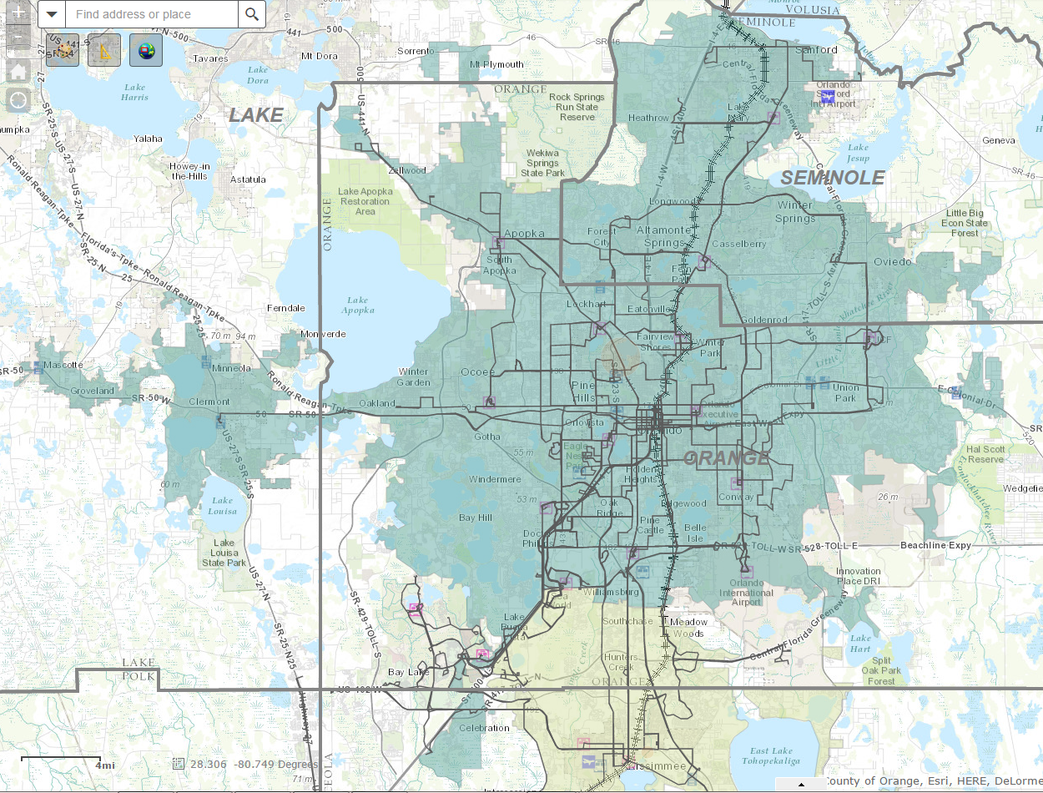

Urbanized Kissimmee Map
Please see the following map for an overview of the Kissimmee Urbanized area.
The map can also be found on the LYNX interactive map website at: http://lynx.maps.arcgis.com/apps/webappviewer/index.html?id=90bfdab26dc2438a93ea0b751394a851
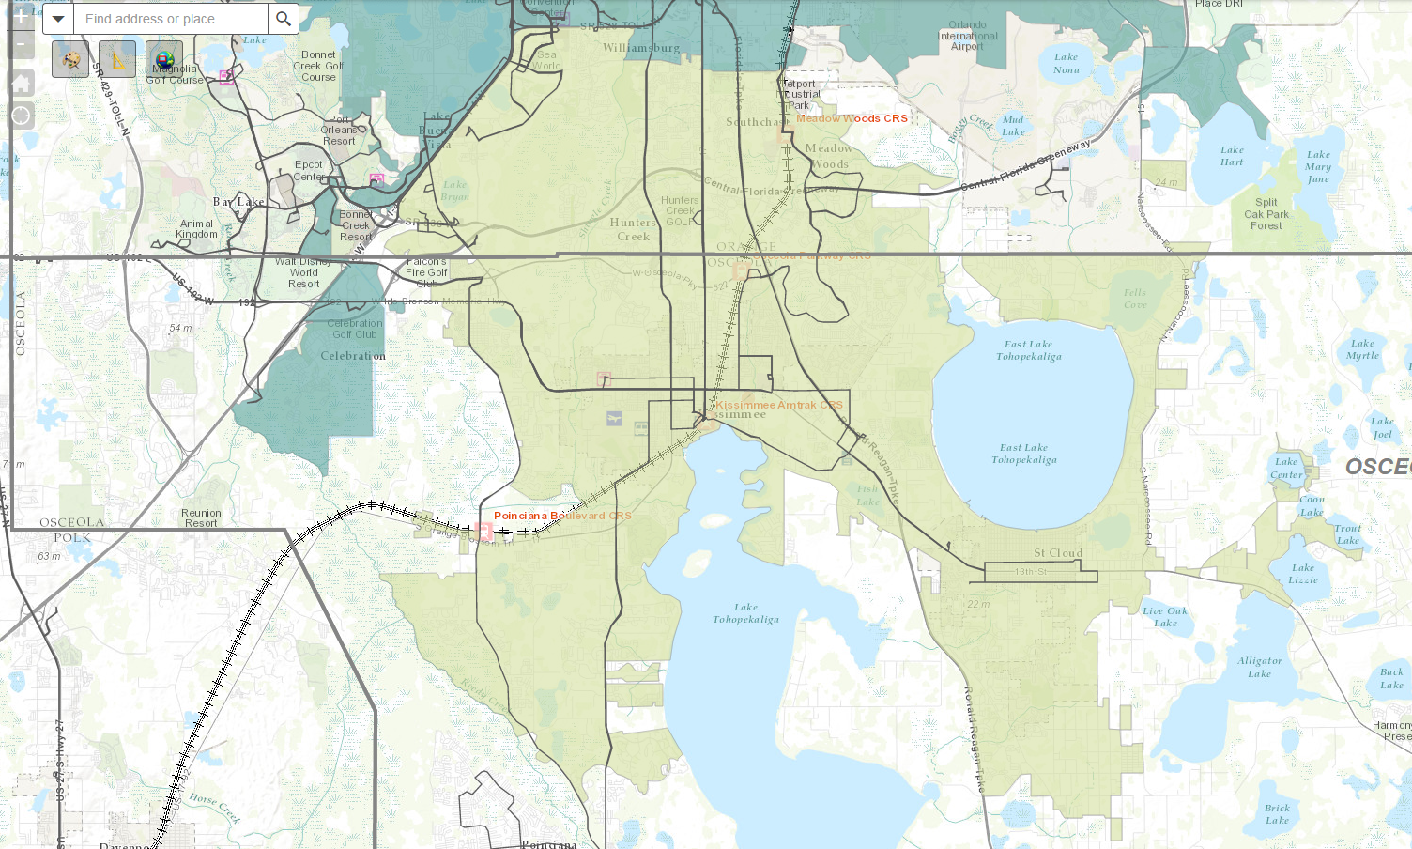

Legal Authority and Fiscal & Managerial Capability
Section 5310 applicants must have the legal authority and fiscal/managerial capability to apply for Federal assistance. Applicants are required to have sufficient local funds for match requirements and for maintenance and operation of vehicles/equipment. Failure to properly manage, maintain, and operate vehicles/equipment could jeopardize existing and future grants and may result in the removal of vehicles/equipment.

Service Across Urbanized/Non-Urbanized Area Boundaries
Applicants providing service across urbanized/non-urbanized area boundaries must employ a method of segregating the costs of services to show the percentage split of services provided within each respective area (urbanized and non-urbanized). Examples of methods that may be used to allocate costs include:
- Where all passenger addresses are known, assume the percentage of those addresses located in urbanized areas equals the level of service in urbanized areas
- Segregate urbanized and non-urbanized service miles based on route maps, and allocate system-wide costs accordingly
- Utilize driver logs to segregate service mileage or hours inside and outside the urbanized area, and allocate costs accordingly
  - Other methods require written concurrence by the CTC before grant application due date.

Americans with Disabilities Act (ADA)
Applicants shall comply with the Americans with Disabilities Act, (ADA) of 1990, as amended; Section 504 of the Rehabilitation Act of 1973, as amended; U. S. DOT regulations, Transportation Services for Individuals with Disabilities (ADA)” at 49 CFR Part 37; and FTA regulations, Transportation for Elderly and Handicapped Persons, 49 CFR Part 609.

Administrative Requirements
Applicants must meet with the CTC prior to submitting an application. The period to meet with the CTC is between August 24 and September 11, 2015. To schedule a meeting with the CTC please contact Tim May at tmay@golynx.com or 407.254.6055.
Applicants shall supply the appropriate Regional Planning Council (RPC)/local clearinghouse agency (see Appendix) a copy of its application for Federal Assistance. Each applicant shall request the RPC/Clearinghouse to provide a letter of approval of the application to LYNX. Copies of correspondence to the RPC/Clearinghouse agency should be contained in the grant application (email correspondence is acceptable).

Matching Funds for Section 5310
The section 5310 vanpools will be funded 50% federal and 50% local cash.

Operating Assistance Matching Funds
The Section 5310 federal share of eligible operating expenses may not exceed 50%. Some combination of state, local, or private funding sources must be identified and committed to provide the required non-federal share. The non-federal share must be cash. Funds may be local, private, state, or (up to one half) unrestricted Federal funds. Funds may not include any borrowed against the value of capital equipment funded in whole or in part by State and/or Federal sources.
The Section 5310 Program permits up to one half of the required match to be derived from other unrestricted Federal funds. Federal funds are unrestricted when a Federal agency permits its funds to match Section 5310. Essentially, all Federal Social Service Programs using transit services are unrestricted; other USDOT Programs are not.
Contract revenue from the provision of transportation services to social service agencies may also be used as local match. The costs associated with providing the contract revenue service must be included in the project budget if using contract revenue as match.
Any funds committed as match to another Federal program may not be used to match Section 5310 funds.

Grant Award Process
The recipient will have to schedule a site visit with LYNX staff to conduct a vehicle, financial and technical capacity inspection. Failure to schedule such visit will result in the forfeiture of award.

Project Evaluation and Selection Process
The designated recipient, LYNX, is responsible for conducting the competitive selection process.
The project evaluation team is made up of individuals that represent the interests of the elderly and persons with disabilities, as well as mobility across the region.
Proposals will be screened and ranked by the project evaluation and selection team. All applicants will be notified of project funding recommendations from the evaluation committee by September 29, 2015. The LYNX Board of Directors will receive the funding recommendations from the evaluation and selection team and will formally adopt the project list. Successful applicants will receive a letter that describes the forms and processes that they will need to complete in order to access FTA funds.
The project evaluation criteria and the factors that will be considered in evaluating the project proposals appear below.

Project Evaluation Criteria and Scoring
The evaluation criteria are based on the submission of clear, complete, and correct applications. The omission of any required elements will result in the application being disqualified.
Applicant responses to the Proposed Project Description questions, the Fact Sheet, Budget, and other elements deemed critical by LYNX will be used to score submissions. The scoring will be based out of 100 points and each element will be weighted at LYNX’ discretion.

Program Performance Measures
Under the Government Performance and Results Act (GPRA), FTA is required to establish performance goals and indicators to measure relevant outputs, service levels, and outcomes for all FTA programs, including 5310.
Below are the program measures stated in FTA Circular 9070.1G (pages II-2 and II-3):
SECTION 5310 PROGRAM MEASURES. Under the Government Performance Results Act (GPRA), FTA is required by law to “establish performance goals to define the level of performance” and to also “establish performance indicators to be used in measuring relevant outputs, service levels, and outcomes” for each of its programs. The performance measures described here are designed to fulfill FTA’s obligations under this Act. These measures will be used at a program level, and will not be used to assess individual grants.
FTA will be capturing overall program measures to be used with the GPRA and the Performance Assessment Rating Tool process for the U.S. Office of Management and Budget. FTA will conduct independent evaluations of the program focused on specific data elements in order to better understand the implementation strategies and related outcomes associated with the program.
The following indicators are targeted to capture overarching program information as part of the annual report that each state and designated recipient submits to FTA. The state and designated recipient should submit both quantitative and qualitative information as available on each of the following measures.
Traditional Section 5310 Projects
  - Gaps in Service Filled. Provision of transportation options that would not otherwise be available for seniors and individuals with disabilities measured in numbers of seniors and people with disabilities afforded mobility they would not have without program support as a result of traditional Section 5310 projects implemented in the current reporting year.
  - Ridership. Actual or estimated number of rides (as measured by one-way trips) provided annually for individuals with disabilities and seniors on Section 5310– supported vehicles and services as a result of traditional Section 5310 projects implemented in the current reporting year.
Other Section 5310 Projects
- Increases or enhancements related to geographic coverage, service quality, and/or service times that impact availability of transportation services for seniors and individuals with disabilities as a result of other Section 5310 projects implemented in the current reporting year.
- Additions or changes to physical infrastructure (e.g., transportation facilities, sidewalks, etc.), technology, and vehicles that impact availability of transportation services for seniors and individuals with disabilities as a result of other Section 5310 projects implemented in the current reporting year.
- Actual or estimated number of rides (as measured by one-way trips) provided for seniors and individuals with disabilities as a result of other Section 5310 projects implemented in the current reporting year.

Application Instructions

Checklist
CHECKLIST FOR APPLICATION COMPLETENESS

Name of Applicant: ___________________________________________________________

The following documents must be included in section 5310 Operating Assistance Applications in the order listed:
_____ This Checklist
_____ Applicant’s Cover Letter (use LYNX cover letter, in Appendix)
_____ Copy of the Governing Board’s Resolution (See Appendix for sample)
_____ Application for Federal Assistance (Standard Form 424)
_____ Budget
_____ Vehicle Inventory
_____ Exhibit A: Current System Description
_____ Exhibit B: Fact Sheet
_____ Exhibit C: Annual Operating Report
_____ Exhibit D: Proposed Project Description and Service Area Maps Detailing the Proposed Service Area (maps provided by LYNX)
_____ Exhibit E: CTC Coordination Contract
_____ Exhibit F: Single Audit Act, or Certification of Exemption from Single Audit Act, if applicable
_____ Exhibit G: Coordinated Public Transit – Human Services Transportation Plan
Date application was submitted to Local Clearinghouse/Regional Planning Council:_____________
(send one (1) copy of letter, or email, received from the Local Clearinghouse/RPC to LYNX)

Standard Form 424
Please complete Standard Form 424 as part of application. An editable pdf can be found at:
http://apply07.grants.gov/apply/forms/sample/SF424_2_1-V2.1.pdf
Please see Example Standard Form 424 on following pages.

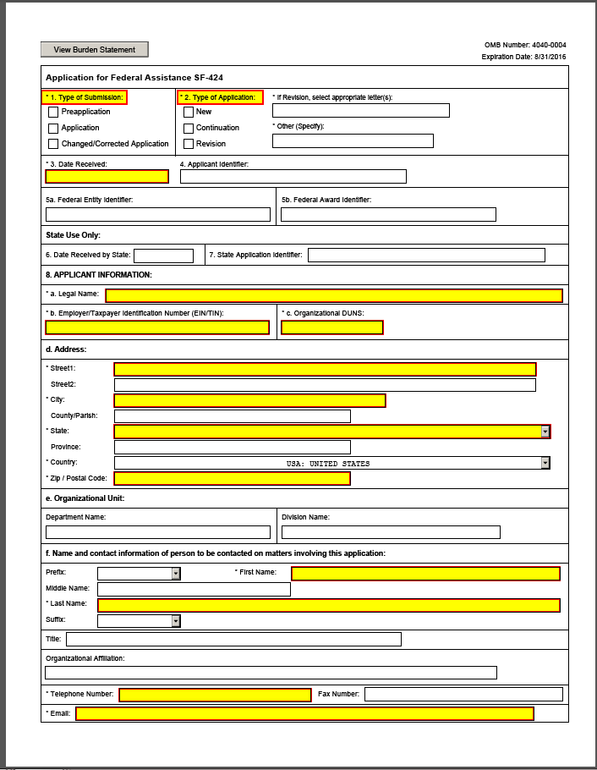
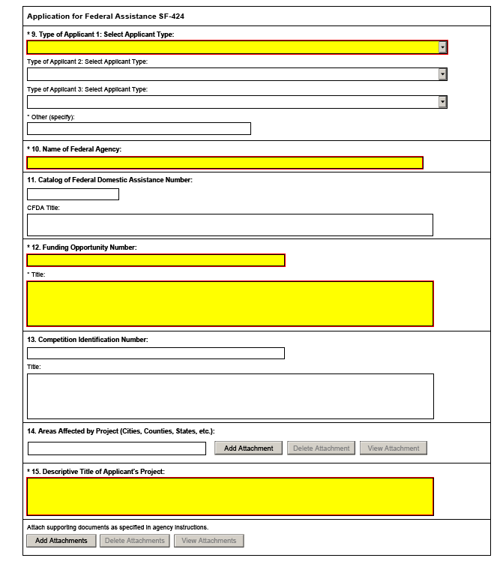

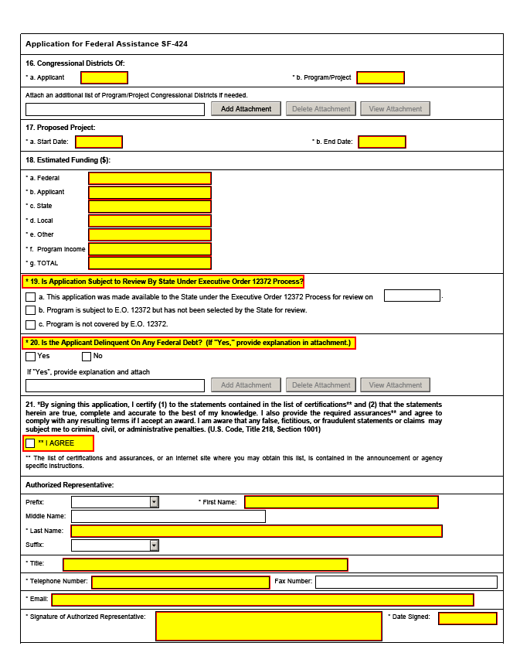

5310 Budget Calculations

Vanpool Budget
1 or 2 Years of Vanpool
Vehicle Type | Quantity | Unit Cost | Months | Total
Vehicle w/ wheelchair access | X | $690 | X {(12) or (24)} | =
Vehicle w/o wheelchair access | X | $690 | X {(12) or (24)} | =
 | TOTAL ESTIMATED VANPOOL COSTS |  |  | =

VANPOOL REQUEST AND CONTRIBUTION SUBTOTALS
FEDERAL REQUEST (50% of Vanpool Costs): $________________ (a)
LOCAL CASH CONTRIBUTION (50% of Vanpool Costs): $________________ (c)

Project-Related Operating Expenses
(Operating expenses for all services proposed in this application)
1 of 2 Years of Operating, please indicate project duration
EXPENSE ITEM | EXPENSE AMOUNT $
Driver Wages and Benefits
Cost of Leases (Vehicles, Equipment, Infrastructure, etc.) (excluding vanpool lease)
Fuel
Maintenance (if not participating in Vanpool program)
Insurance (if not participating in Vanpool program)
Administrative Staff Wages
Other (Modify the form to list all that apply)
PROJECT OPERATING EXPENSES

Project-Related Revenue
(Do not include funding requested in this application)
REVENUE ITEM | REVENUE AMOUNT $
Federal Grants or Subsidies
State Grants or Subsidies
Local Grants or Subsidies
Revenues from Advertising or Similar
Fares or User Fees
Other (Modify the form to list all that apply)
PROJECT REVENUE
Net Project Cost
Project Operating Expenses - Project Revenue = Net Project Cost

$____________ - $_______________ = $_____________

PROJECT OPERATING REQUEST AND CONTRIBUTION SUBTOTALS
FEDERAL REQUEST (Net Project Cost): $____________ (b)
LOCAL CONTRIBUTION (Project Revenue – Fares/User Fees): $____________ (d)

TOTAL PROJECT GRANT REQUEST AND CONTRIBUTION
(Vanpool Subtotals + Project Operating Subtotals)

FEDERAL REQUEST (a + b): $_________________
LOCAL CASH CONTRIBUTION (c + d): $_________________

Local Match
Identify the specific sources of funds (public and private) to be used as local contribution. Applicants may provide local match from other federal programs that are eligible to be expended for transportation, with the exception of USDOT/FTA programs. In addition, state the dollar amount associated with each local match funding source.

Current Vehicle Inventory
(vehicles currently used by agency/organization)
Model  Yr. | Make / size / type | FDOT control #  or VIN | Wheelchair Ramp or Lift  (specify) | Seats & W/C positions  (i.e. 12+2) | Avg. miles/Yr. | Current Mileage | Expected retirement date | Other equipment (GPS, onboard computer) | Funding source used to Purchase Vehicle | Urban Service Area (Y/N)

Anticipated / Requested Vehicles
(vehicles requested through this grant, other funding sources, or already purchased but not yet in service)
Replacement or Expansion Vehicle | FDOT control #  or VIN of Vehicle Replacing | Make / size / type | Ramp or lift  (specify) | Seats & W/C positions  (i.e. 12+2) | Expected Avg. miles/Yr. | Expected retirement date | Other equipment (GPS, onboard computer)

Exhibit “A” – Current System Description

NOTE: Applicable only if applicant does not have an active coordination contract with the CTC.

Applicants must submit Exhibit A as part of their application. Exhibit A should provide a short description of who the applicant is and what services they provide. It is requested that applicants provide the System Description in a question/answer format. Please limit response to two pages. The following information shall be included in the narrative in a detailed manner:

- An overview of the organization including its mission, program goals and objectives
- Organizational structure, type of operation, number of employees, and other pertinent organizational information
- Who is responsible for insurance, training and management, and administration of the agencies transportation programs
- Who provides maintenance of the vehicles
- Number of transportation related employees (drivers, schedulers, dispatchers, etc.)
- Who will drive the vehicle, number of drivers, CDL certifications, etc.
- A detailed description of service routes/areas and ridership numbers

Exhibit “B” – Fact Sheet (Quick Reference)

Fact Sheet  Performance Measures | CURRENT  (no grant) | IF GRANT IS AWARDED  (Estimates are acceptable.)
1. Number of total one-way passenger trips served by the agency PER YEAR (for all purposes)
2. Number of one-way passenger trips provided to elderly and persons with disabilities PER YEAR
3. Operating Cost per passenger
4. Operating Cost per hour of service
5. Operating Cost per mile of service
6. Normal number of days that vehicles are in operation to provide elderly and disabled persons service PER WEEK
7. Posted hours of normal operation to provide elderly and disabled persons service PER WEEK | M – F:  Saturday:  Sunday:  Total (WEEK): | M – F:  Saturday:  Sunday:  Total (WEEK):

NOTE: Applicant must show methodology/math for determining each value.

Exhibit “C” – Annual Operating Report (AOR)
As support for the information provided on the Budget Calculation pages and in Exhibit B, please provide a copy of the most recent Annual Operating Report (AOR).
The following pages are templates of the pages required for application submission.

Exhibit “D” – Proposed Project Description

The proposed project description should be thorough as the evaluation committee will rely heavily on the narrative in reviewing and ranking a grant application. It is required that all applicants provide the Project Description in a question/answer format.
- How will the project meet the purpose of the 5310 program, as outlined in the “Background” section of this document?
- How will the project address the priorities for the Urbanized Orlando and Kissimmee areas, as outlined in the “Background” section of this document?
- Will the project maintain existing services, expand existing services, or provide a new service?
  - If maintaining existing services, will the quality or efficiency of service improve?
  - If an expansion of existing services, how does this project achieve that expansion (i.e. through increased service hours, increased number of vehicles in service, coordination with other transportation providers, expanded service area, etc.)?
  - If a new service, what is the demand for such a project (what factors led to this project’s development; what analysis was conducted to verify need/demand)?
- How does the proposed project fit into the coordinated transportation system in the LYNX service area? (The required conversation with CTC will help with answering this question)
- Please explain the geographic location of your proposed service area. Will the service operate entirely within the urbanized areas of Orlando and/or Kissimmee, or will some of the services span both urban and non-urbanized areas?
  - If services span both urban and non-urbanized areas, please explain the methodology used to determine this project will predominately serve the urbanized areas.
  - The maps provided by LYNX must be marked up clearly (in color please) to show the proposed service areas and included in the grant application.
- What priorities does the project address in the LYNX TDSP?
  - Are unmet needs or gaps (temporal or geographic) addressed by this project? Which? Please cite the pages and specific references from the TDSP for support.
- If this project helps realize service (operational) efficiencies; what are those efficiencies? How does the project help realize those efficiencies?
- What population(s) will the project serve (elderly, disabled, other transportation disadvantaged groups, general population)?
- How does the project provide a service that the CTC cannot, or at a more efficient rate than the CTC?
- Will the project be sustainable after initial award, or is it only feasible to provide the service(s) with the support of these funds?
  - If applicable, how will the project become sustainable?

Exhibit “E” – CTC Coordination Contract
(If applicable at time of application submission)

Coordination
A copy of the written coordination agreement between the applicant and the CTC in the appropriate service area should be identified as Exhibit E and included in the application. The agreement must be specific as to how the services to be provided will complimentary to the services the CTC provides, and how duplication and fragmentation of services will be avoided. If the applicant’s service extends into areas covered by more than one CTC, copies of all applicable coordination agreements should be included in the application.
If agency does not have a current Coordination Contract with the CTC, a letter of intent to do so is required in place of the contract for Exhibit “E”.
Grant awards will not be made without an appropriate coordination agreement.

Exhibit “F” – Single Audit, or Certification of Exemption

NOTE: In this space, Applicants will provide their most recent Single Audit Report, with any findings and corrective actions; or, if the audit is not applicable, Applicants will provide a Certification of Exemption from Single Audit Act.

Certification of Exemption from Single Audit Act
IT IS HEREBY CERTIFIED THAT the Applicant:

1. Will not receive $750,000 or more for the current Fiscal Year from all federal sources combined, and is, therefore, exempt from the Single Audit Act as described in OMB A-133; and
2. In the event the applicant does receive $750,000 or more in total from all federal sources during the current fiscal year, the applicant will comply with the Single Audit Act and submit LYNX a copy of its most recent audit conducted in compliance with the Act.

______________________________________ ______________________________ ___________
(Typed name and title of authorized individual) (Signature of authorized individual) (Date)

Exhibit “G” – Coordinated Public Transit-Human Services Transportation Plan

Coordinated Public Transit-Human Services Transportation Plan
To be completed and signed by an individual authorized by the governing board of the applicant agency and submitted with the grant application.
The ______________________________________certifies and assures to the Central Florida Regional Transportation Authority (dba LYNX) in regard to its Application for Assistance under U.S.C. Section 5310 dated _______________:
This grant request is derived from a coordinated plan compliant with Federal Transit Administration Circular 9070.1G.
- The name of this coordinated plan is:
______________________________________________________________________________

- The agency that adopted this coordinated plan was:
______________________________________________________________________________

- The date the coordinated plan was adopted was:
______________________________________________________________________________

- The page number of the coordinated plan that this application supports:
______________________________________________________________________________

Date: _________________________ Signature: ____________________________________
____________________________________
Typed name and title

Appendix

Glossary

community transportation coordinator (CTC) - A transportation entity recommended by an MPO, or by the appropriate designated official planning agency, as provided for in Sections 427.015(1), Florida Statutes, in an area outside the purview of an MPO, to ensure that coordinated transportation services are provided to the transportation disadvantaged population in a designated service area.
disabled person – See elderly individual and individual with disabilities.
elderly individual – includes, at a minimum, all persons 65 years of age or older. Grantees may use a definition that extends eligibility for service to younger (e. g., 62 and older, 60 and over) persons.
individual with a disability – means an individual who, because of illness, injury, age, congenital malfunction, or other incapacity or temporary or permanent disability (including an individual who is a wheelchair user or has semi-ambulatory capability), cannot use effectively, without special facilities, planning or design, public transportation service or a public transportation facility.
locally developed, coordinated public transit-human services transportation plan – means a plan that identifies the transportation needs of individuals with disabilities, older adults, and people with low incomes, provide strategies for meeting those local needs, and prioritizes transportation services for funding and implementation. Projects considered for Section 5310 funding must serve identified needs of the disabled population. A locally developed Transportation Disadvantages Services Plan (TDSP) will qualify in most instances. All stakeholders identified in the circular must be included in the development of the TDSP.
non-urbanized area - The area outside of an urbanized area, as defined by the U.S. Bureau of the Census.
one-way passenger trips - A person who rides a transportation vehicle in one direction between two points for a specific purpose.
public transportation – shared ride surface transportation services.
unrestricted Federal funds – funds received by Section 5310 applicants pursuant to service agreements with state or local social service agencies or private social service organizations, and used to match Section 5310 funds, even though the original source of such funds may have been another Federal program.
urbanized area – means an area encompassing a population of not less than 50,000 people that has been defined and designated in the most recent decennial census as an “urbanized area” by the Secretary of Commerce. Small urbanized areas as used in the context of Federal Transit Administration formula grant programs are urbanized areas with a population of at least 50,000 but less than 200,000.
Vehicle hour – the total time spent operating vehicles; including in between passenger trips, travel to initial pick-up and from final drop-off.

Sample Resolution Form

RESOLUTION FORM
A RESOLUTION of the ______________ (Governing Body)__________________________ authorizing the signing and submission of a grant application and supporting documents and assurances to the Central Florida Regional Transportation Authority (dba LYNX), and the acceptance of a grant award from LYNX.
WHEREAS, __________________ (Applicant) ______________________________
has the authority to apply for and accept grant awards made by LYNX as authorized by Chapter 341, Florida Statutes and/or by the Federal Transit Administration Act of 1964, as amended;
NOW, THEREFORE, BE IT RESOLVED BY THE _______________ (Governing Body)_____
________________________________________, FLORIDA:
- This resolution applies to Federal Program(s) under U.S.C. Section(s) _________________.

- The submission of a grant application(s), supporting documents, and assurances to the Florida Department of Transportation is approved.

- ______________ (Authorized Individual by Name and Title) _____________is authorized to sign the application and accept a grant award, unless specifically rescinded.

DULY PASSED AND ADOPTED THIS _____________________________ , 20_____
By: ______________________________
(Signature)
______________________________
(Typed name & title)

ATTEST:
__________________________ (seal)

Required Cover Letter

COVER LETTER
CENTRAL FLORIDA REGIONAL TRANSPORTATION AUTHORITY
GRANT APPLICATION
____________________ (agency name) submits this Application for the Section 5310 Program Grant and agrees to comply with all assurances and exhibits attached hereto and by this reference made a part thereof, as itemized in the Checklist for Application Completeness.

___________________ (agency name) further agrees, to the extent provided by law (in case of a government agency in accordance with Sections 129.07 and 768.28, Florida Statutes) to indemnify, defend and hold harmless LYNX and all of its officers, agents and employees from any claim, loss, damage, cost, charge, or expense arising out of the non-compliance by the Agency, its officers, agents or employees, with any of the assurances stated in this Application.

This Application is submitted on this _______ day of ____________, 20 ___ with two (2) original resolutions or certified copies of the original resolution authorizing _________________ (Name & Title) to sign this Application.
Agency Name

By ____________________ Date__________

Title ________________________________

List of Clearinghouses / Regional Planning Councils
- East Central Florida RPC
  - Brevard, Lake, Orange, Osceola, Seminole, Volusia
  - 309 Cranes Roost Boulevard Suite 2000, Altamonte Springs, FL 32701
  - Contact: Mr. Hugh W. Harling, Jr. Email: hharling@ecfrpc.org ; 407-262-7772

LYNX Contacts
Belinda Balleras – Manager of Grants; bballeras@golynx.com ; 407.254.6115
Tim May – Manager of Paratransit; tmay@golynx.com ; 407.254.6055
Selita Stubbs – Grants & Budget Compliance Analyst; smaldonado@golynx.com ; 407.254.6148
Myles O’Keefe – Senior Planner; mokeefe@golynx.com ; 407.254.6076
Christopher Smullins – vRide Contractor; csmullins@golynx.com; 407.254.6016

END OF MANUAL

