Fiscal Year 2018

49 U.S.C. Section 5310 | FAST Act Section 3006
Enhanced Mobility of Seniors and Individuals with Disabilities

5310 GRANT APPLICATION
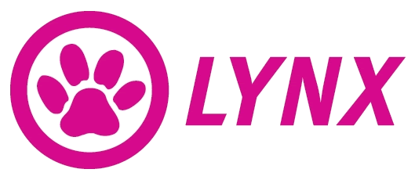

Central Florida Regional Transportation Authority

Checklist for Application Assistance

Name of Applicant:

The following documents must be included in section 5310 Operating Assistance Applications in the order listed:

This Checklist
Applicant’s Cover Letter (use LYNX cover letter, see Appendix A)
Applicant History
Application for Federal Assistance (Standard Form 424 – See Appendix F for sample)
Annual Operating Data (Excel Worksheet)
Budget (Excel Worksheet)
Local Match (Excel Worksheet)
Fact Sheet (Excel Worksheet)
Vehicle Inventory (Excel Worksheet)
Current System Description
Proposed Project Description
Service Area Maps (LYNX provided maps)
Federal Certifications and Assurances
Exhibit A: CTC Coordination Contract
Exhibit B: Single Audit Act, or Certification of Exemption from Single Audit Act, if applicable (See Appendix B for sample)
Exhibit C: Coordinated Public Transit – Human Services Transportation Plan (See Appendix C for sample)
Exhibit D: Copy of the Governing Board’s Resolution (See Appendix D for sample)
Exhibit E: Certification of Equivalent Service (See Appendix E for sample)

Applicant History
- Type of Applicant (place X in box):

 | New |  | Existing

- Have you had a Section 5310 project funded by LYNX (place X in box)?

 | Yes |  | No

- If YES, briefly describe your previously funded Section 5310 project and summarize project outcomes for the clients/populations served by your agency:

Cover Letter
Please complete the template form included in the Appendix. When application is submitted, please print and attach a copy of the completed form.

Standard Form 424
Please complete Standard Form 424 as part of application. An editable pdf can be found at:
Standard Form 424
Standard Form 424 Instructions
Please see Example Standard Form 424 in Appendix F.

Required Excel Documents

Annual Operating Data
As support for the information provided on the Budget and in the Fact Sheet, please complete the Fact Sheet in the Excel Workbook provided on the thumb drive. When application is submitted, please print and attach a copy of the completed “Annual Operating Data” worksheet.

5310 Budget
Please complete the 5310 Budget in the Excel Workbook provided on the thumb drive. When application is submitted, please print and attach a copy of the completed “Budget” worksheet.

Local Match
Please complete the Local Match form in the Excel Workbook provided on the thumb drive. Identify the specific sources of funds (public and private) to be used as local contribution. Applicants may provide local match from other federal programs that are eligible to be expended for transportation, with the exception of USDOT/FTA programs. In addition, state the dollar amount associated with each local match funding source.

Fact Sheet
Please complete the Fact Sheet in the Excel Workbook provided on the thumb drive. When application is submitted, please print and attach a copy of the completed “Fact Sheet” worksheet.

Vehicle Inventory
Please complete the Vehicle Inventory in the Excel Workbook provided on the thumb drive. When application is submitted, please print and attach a copy of the completed form.

Current System Description
It is requested that applicants provide the System Description in a question/answer format. Please limit response to two pages. The following information shall be included in the narrative in a detailed manner:
- An overview of the organization including its mission, program goals, and how transportation fits into the overall organization mission

- Organizational structure, type of operation, number of employees, and other pertinent organizational information

- Who is responsible for insurance, training and management, and administration of the agencies transportation programs

- Who provides maintenance of the vehicles

- Number of transportation related employees (drivers, schedulers, dispatchers, etc.)

- Who will drive the vehicle, number of drivers, CDL certifications, etc.?

- A detailed description of service routes/areas and ridership number

Proposed Project Description
The proposed project description should be thorough as the evaluation committee will rely heavily on the narrative in reviewing and ranking a grant application. It is required that all applicants provide the Project Description in a question/answer format.
- How will the project meet the purpose of the 5310 program, as outlined in the Application Manual?

- How will the project address the priorities for the Urbanized Orlando and Kissimmee areas, as outlined in the “2016 Program Goals and Priorities” section of the Application Manual?

- Will the project maintain existing services, expand existing services, or provide a new service?
  - If maintaining existing services, will the quality or efficiency of service improve?
  - If an expansion of existing services, how does this project achieve that expansion (i.e. through increased service hours, increased number of vehicles in service, coordination with other transportation providers, expanded service area, etc.)?
  - If a new service, what is the demand for such a project (what factors led to this project’s development; what analysis was conducted to verify need/demand)?

- How does the proposed project fit into the coordinated transportation system in the LYNX service area? (The required conversation with CTC will help with answering this question)

- Please explain the geographic location of your proposed service area. Will the service operate entirely within the urbanized areas of Orlando and/or Kissimmee, or will some of the services span both urban and non-urbanized areas?
  - If services span both urban and non-urbanized areas, please explain the methodology used to determine this project will predominately serve the urbanized areas.
  - The maps provided by LYNX must be marked up clearly (in color please) to show the proposed service areas and included in the grant application.

- What priorities does the project address in the LYNX TDSP?
  - Are unmet needs or gaps (temporal or geographic) addressed by this project? Which? Please cite the pages and specific references from the TDSP for support.

- If this project helps realize service (operational) efficiencies; what are those efficiencies? How does the project help realize those efficiencies?

- What population(s) will the project serve (elderly, disabled, other transportation disadvantaged groups, general population)?

- How does the project provide a service that the CTC cannot, or at a more efficient rate than the CTC?

- Will the project be sustainable after initial award, or is it only feasible to provide the service(s) with the support of these funds?
  - If applicable, how will the project become sustainable?

Single Audit Act, or Certification of Exemption from Single Audit Act
Applicants will provide their most recent Single Audit Report, with any findings and corrective actions; or, if the audit is not applicable, Applicants will provide a Certification of Exemption from Single Audit Act.

Please complete the template form included in Appendix B. When application is submitted, please print and attach a copy of the completed form.

CTC Coordination Contract
A copy of the written coordination agreement between the applicant and the CTC in the appropriate service area should be identified as Attachment B and included in the application. The agreement must be specific as to how the services to be provided will complimentary to the services the CTC provides, and how duplication and fragmentation of services will be avoided. If the applicant’s service extends into areas covered by more than one CTC, copies of all applicable coordination agreements should be included in the application.

If agency does not have a current Coordination Contract with the CTC, a letter of intent to do so is required in place of the contract. Grant awards will not be made without an appropriate coordination agreement.

Coordinated Public Transit – Human Services Transportation Plan
Please complete the template form included in the Appendix C. When application is submitted, please print and attach a copy of the completed form.

Governing Board’s Resolution
Please complete the template form included in the Appendix D. When application is submitted, please print and attach a copy of the completed form.

Certifications and Assurances
All application must include the most recent signed copy of the FTA Certifications and Assurances. These can be found at the following link: https://www.transit.dot.gov/sites/fta.dot.gov/files/FTA%20FY%202017%20Certifications%20and%20Assurances.pdf

Certificate of Equivalent Service
According to Circular 9070.iG providers of demand responsive service must utilize accessible vehicles, as defined at 49 CFR 37.7 or meet the applicable equivalent service standard. For private and public entities, the service must be equivalent in regard to schedules, response times, geographic areas of service, hours and days of service, availability of information, reservations capability, constraints on capacity or service availability, and restrictions based on trip purpose. If a sub-recipient does not have wheelchair accessible vehicles available, a Certificate of Equivalent Service must be on file with LYNX at time of application and should be submitted with the 5310 Application. A certification of Equivalent Service has been provided in Appendix E.
APPENDIX

Appendix A: Cover Letter Template
Appendix B: Certification of Exemption from Single Audit Act
Appendix C: Coordinated Public Transit-Human Services Transportation Plan
Appendix D: Governing Board’s Resolution
Appendix E: Certification of Equivalent Service
Appendix F: Example Standard Form 424
Appendix G: Glossary

Appendix A: Cover Letter Template

CENTRAL FLORIDA REGIONAL TRANSPORTATION AUTHORITY GRANT APPLICATION

(agency name) submits this Application for the Section 5310 Program Grant and agrees to comply with all assurances and exhibits attached hereto and by this reference made a part thereof, as itemized in the Checklist for Application Completeness.

(agency name) further agrees, to the extent provided by law (in case of a government agency in accordance with Sections 129.07 and 768.28, Florida Statutes) to indemnify, defend and hold harmless LYNX and all of its officers, agents and employees from any claim, loss, damage, cost, charge, or expense arising out of the non-compliance by the Agency, its officers, agents or employees, with any of the assurances stated in this Application.

This Application is submitted on this day of , 20 with two (2) original resolutions or certified copies of the original resolution authorizing (Name & Title) to sign this Application.

Agency Name

By _ Date

Title

Appendix B: Certification of Exemption from Single Audit Act

IT IS HEREBY CERTIFIED THAT the Applicant:

- Will not receive $750,000 or more for the current Fiscal Year from all federal sources combined, and is, therefore, exempt from the Single Audit Act as described in OMB A-133; and
- In the event the applicant does receive $750,000 or more in total from all federal sources during the current fiscal year, the applicant will comply with the Single Audit Act and submit LYNX a copy of its most recent audit conducted in compliance with the Act.

(Typed name and title of authorized individual) (Signature of authorized individual) (Date)

Appendix C: Coordinated Public Transit-Human Services Transportation Plan

To be completed and signed by an individual authorized by the governing board of the applicant agency and submitted with the grant application.
The certifies and assures to the Central Florida Regional Transportation Authority (dba LYNX) in regard to its Application for Assistance under
    - Section 5310 dated :

This grant request is derived from a coordinated plan compliant with Federal Transit Administration Circular 9070.1G.
      - The name of this coordinated plan is:

      - The agency that adopted this coordinated plan was:

Central Florida Regional Transportation Authority dba LYNX

      - The date the coordinated plan was adopted was:

      - The page number of the coordinated plan that this application supports:

Date: Signature:

Name and Title

Appendix D: Governing Board’s Resolution

A RESOLUTION of the (Governing Body) authorizing the signing and submission of a grant application and supporting documents and assurances to the Central Florida Regional Transportation Authority (dba LYNX), and the acceptance of a grant award from LYNX.

WHEREAS, (Applicant) has the authority to apply for and accept grant awards made by LYNX as authorized by Chapter 341, Florida Statutes and/or by the Federal Transit Administration Act of 1964, as amended;
NOW, THEREFORE, BE IT RESOLVED BY THE (Governing
Body)

, FLORIDA:

- This resolution applies to Federal Program(s) under U.S.C. Section(s)
.
- The submission of a grant application(s), supporting documents, and assurances to the CFRTA is approved.
- (Authorized Individual by Name and Title) is authorized to sign the application and accept a grant award, unless specifically rescinded.

DULY PASSED AND ADOPTED THIS , 20

By: (Signature)

(Typed name & title)

ATTEST:

(seal)

Appendix E: Certification of Equivalent Service

CERTIFICATION OF EQUIVALENT SERVICE
(Agency Name) certifies that its demand responsive service offered to individuals with disabilities, including individuals who use wheelchairs, is equivalent to the level and quality of service offered to individuals without disabilities. Such service, when viewed in its entirety, is provided in the most integrated setting feasible and is equivalent with respect to:
- Response time;
- Fares;
- Geographic service area;
- Hours and days of service;
- Restrictions on trip purpose;
- Availability of information and reservation capability; and
- Constraints on capacity or service availability.
In accordance with 49 CFR Part 37, public entities operating demand responsive systems for the general public which receive financial assistance under 49 U.S.C. 5310 and 5311 of the Federal Transit Administration (FTA) funds must file this certification with the appropriate state program office before procuring any inaccessible vehicle. Such public entities not receiving FTA funds shall also file the certification with the appropriate state office program. Such public entities receiving FTA funds under any other section of the FTA Programs must file the certification with the appropriate FTA regional office. This certification is valid for no longer than one year from its date of filing. Non-public transportation systems that serve their own clients, such as social service agencies, are required to complete this form.

Executed this Date day of Month, Year
(Name and title of authorized representative)

(Signature of authorized representative)

Appendix F: Example Standard Form 424
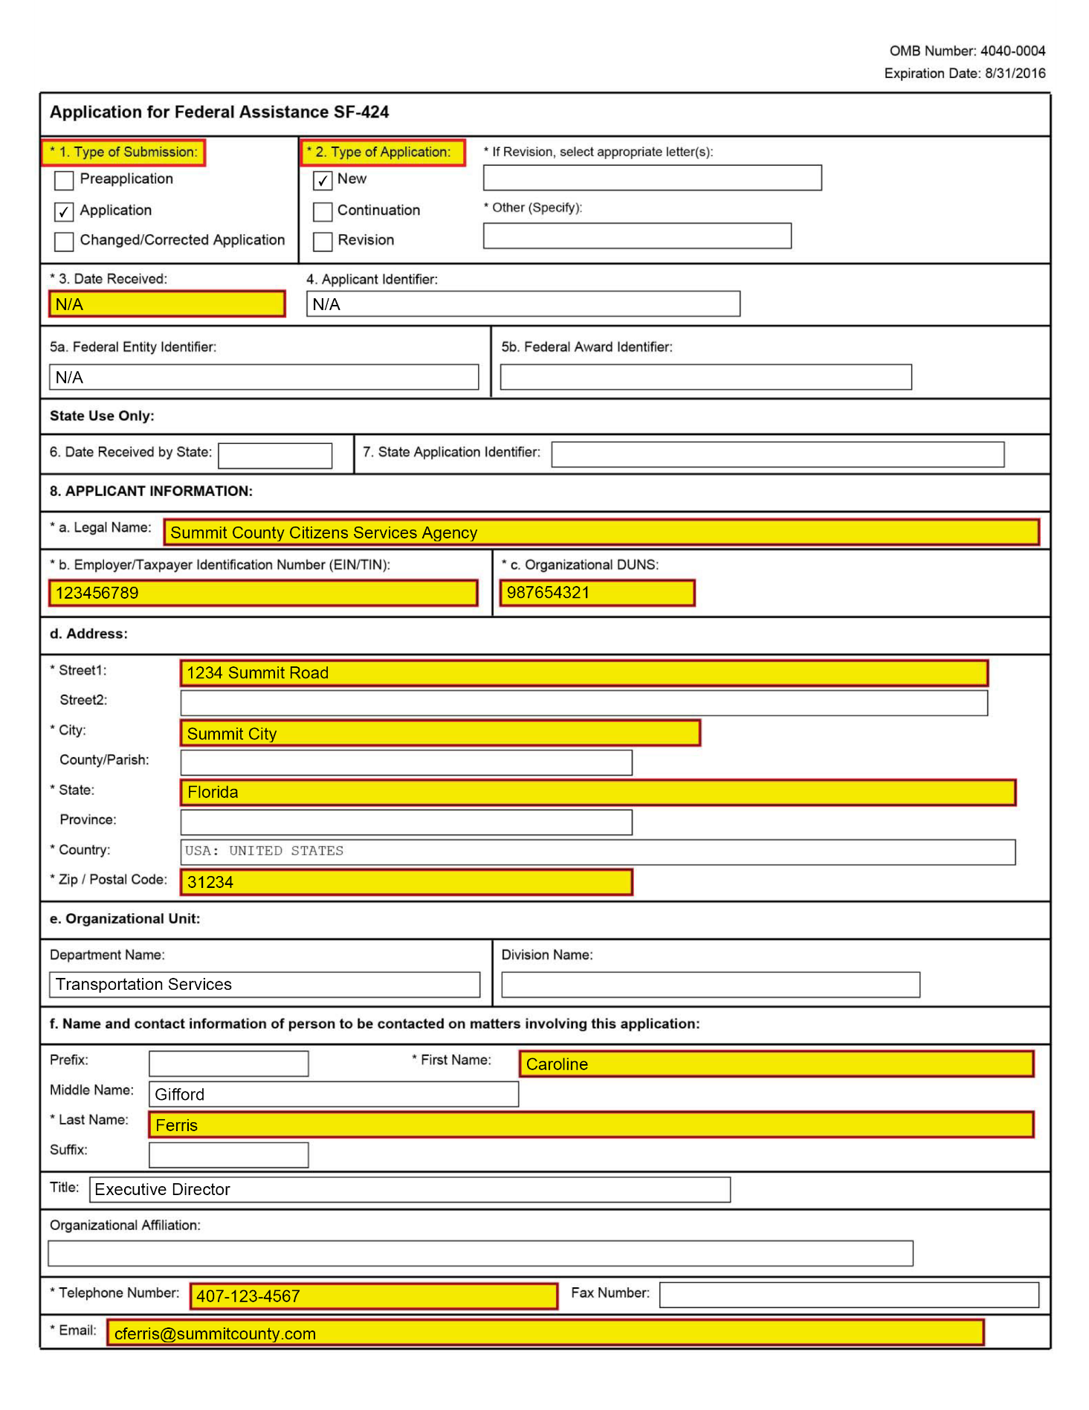
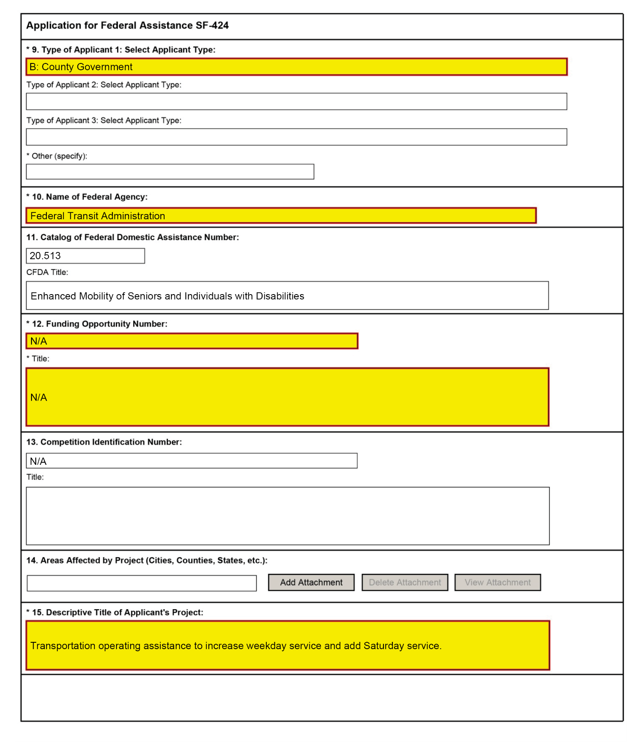
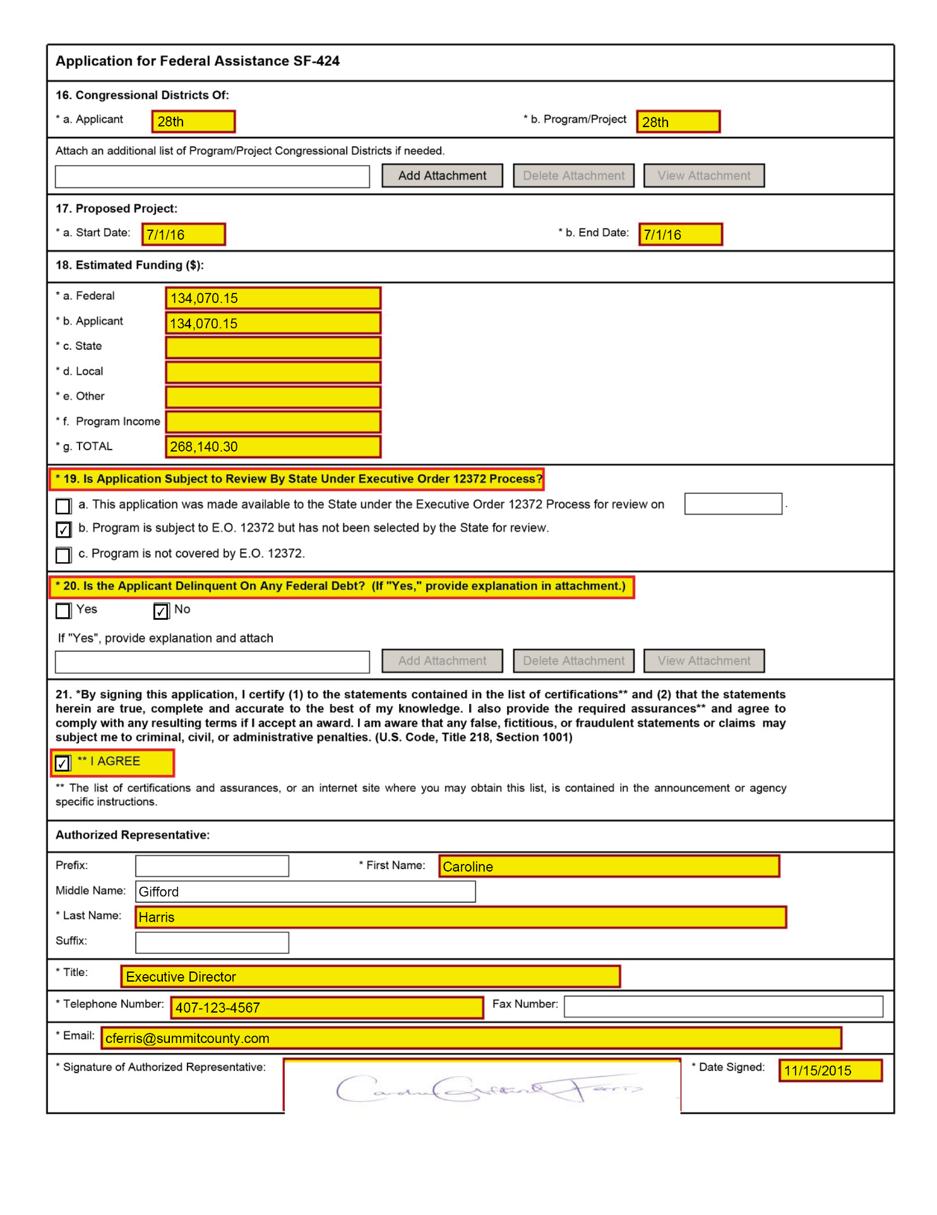

Appendix G: Glossary
Community Transportation Coordinator (CTC) - A transportation entity recommended by an MPO, or by the appropriate designated official planning agency, as provided for in Sections 427.015(1), Florida Statutes, in an area outside the purview of an MPO, to ensure that coordinated transportation services are provided to the transportation disadvantaged population in a designated service area.
Disabled person – See elderly individual and individual with disabilities.

Elderly individual – includes, at a minimum, all persons 65 years of age or older. Grantees may use a definition that extends eligibility for service to younger (e. g., 62 and older, 60 and over) persons.

Individual with a disability – means an individual who, because of illness, injury, age, congenital malfunction, or other incapacity or temporary or permanent disability (including an individual who is a wheelchair user or has semi-ambulatory capability), cannot use effectively, without special facilities, planning or design, public transportation service or a public transportation facility.

Locally developed, coordinated public transit-human services transportation plan – means a plan that identifies the transportation needs of individuals with disabilities, older adults, and people with low incomes, provide strategies for meeting those local needs, and prioritizes transportation services for funding and implementation. Projects considered for Section 5310 funding must serve identified needs of the disabled population. A locally developed Transportation Disadvantages Services Plan (TDSP) will qualify in most instances. All stakeholders identified in the circular must be included in the development of the TDSP.

Non-urbanized area - The area outside of an urbanized area, as defined by the U.S. Bureau of the Census.

One-way passenger trips - A person who rides a transportation vehicle in one direction between two points for a specific purpose.

Public transportation – shared ride surface transportation services.

Unrestricted Federal funds – funds received by Section 5310 applicants pursuant to service agreements with state or local social service agencies or private social service organizations, and used to match Section 5310 funds, even though the original source of such funds may have been another Federal program.

Urbanized area – means an area encompassing a population of not less than 50,000 people that has been defined and designated in the most recent decennial census as an “urbanized area” by the Secretary of Commerce. Small urbanized areas as used in the context of Federal Transit
Administration formula grant programs are urbanized areas with a population of at least 50,000 but less than 200,000.

Vehicle Hour – the total time spent operating vehicles; including in between passenger trips, travel to initial pick-up and from final drop-off.

Vehicle Mile - the total miles traveled while operating vehicles; including in between passenger trips, travel to initial pick-up and from final drop-off.

Vehicle Revenue Hour - the hours that passenger cars travel while in revenue service; revenue service begins when a passengers enters the vehicle and ends when a passenger exits the vehicle.

Vehicle Revenue Mile - the miles that passenger cars travel while in revenue service; revenue service begins when a passengers enters the vehicle and ends when a passenger exits the vehicle.

